Ideation

PhaseBrainstorm & IdeaPrioritiation Template

|  |  |
| --- | --- |
|  |  |
| TeamID | PNT2022TMID49411 |
| ProjectName | SmartSolutionforRailways |
| MaximumMarks | 4Marks |

**Step-1:TeamGathering,CollaborationandSelecttheProblemStatement**

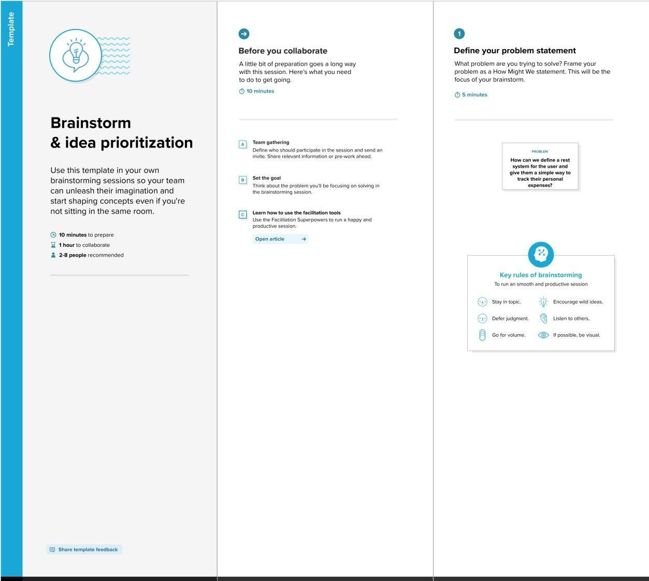

Step-2: Brainstorm,IdeaListingandGrouping

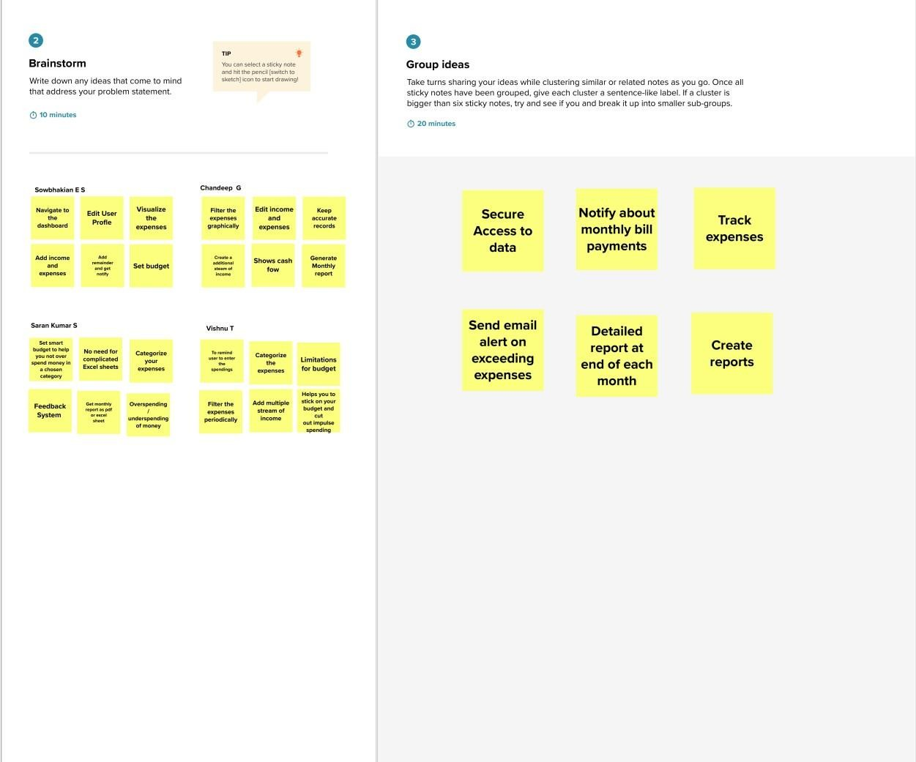

Step-3: IdeaPrioritization

